National Institute Of Technology – Calicut
Data Mining

R programming

T.G. Deshan K. Sumanathilaka
B150413CS
Computer Science and Engineering
(B.Tech)

DATA-MINING ASSIGNMENT #02

A) K means clustering with k=actual number of classes

kidney_noc <- read.csv("/home/deshan/Desktop/clean_kidney_kmean.csv")
cols <- c(1:5, 10:18)
ans <- kmeans(kidney_noc[, cols], 2)
ans

K-means clustering with 2 clusters of sizes 145, 255

Cluster means:
age bp sg al su bgr bu sc sod pot hemo
1 48.05850604 75.09936011 1.019482759 0.7379310345 0.1862068966 135.4104223 55.08658160 2.961808759 137.0499835 4.759555779 13.09259612
2 53.43085101 77.24792803 1.016705882 0.9921568627 0.5137254902 155.2160608 58.75582112 3.135370384 137.8009961 4.552007388 12.20450309
pcv wbcc rbcc
1 40.46657582 6227.586207 4.771752345
2 37.98488574 9644.897959 4.670862333

Clustering vector:
[1] 1 1 1 1 1 1 2 1 2 2 2 1 2 2 2 1 2 2 2 1 2 1 1 2 2 2 2 2 2 2 2 1 2 2 2 2 2 1 2 2 2 2 2 1 2 2 1 2 2 2 2 2 1 2 2 2 2 2 1 2 2 2 1 2 2 2
[67] 2 2 2 1 2 2 2 1 1 2 1 1 2 2 2 1 2 2 1 2 2 1 2 2 2 2 1 1 2 2 2 2 1 2 2 2 1 2 2 1 1 2 2 2 2 2 2 2 2 1 2 2 2 2 2 2 2 2 1 2 2 2 1 2 2 2
[133] 2 2 2 2 2 2 2 2 2 1 2 2 2 1 2 2 2 2 1 2 2 2 2 1 2 1 2 2 2 2 1 2 2 2 2 1 1 2 2 2 2 2 2 1 2 2 2 2 2 2 2 2 1 2 2 2 2 1 2 2 2 1 2 2 2 1
[199] 2 2 1 2 2 2 2 2 2 2 1 1 2 2 2 1 1 2 2 2 1 2 2 2 2 2 2 2 1 1 2 2 2 2 2 2 1 1 2 2 2 2 1 1 2 2 2 1 1 2 2 1 2 2 2 1 2 2 2 2 2 1 2 1 1 2
[265] 1 2 1 2 2 1 1 2 1 2 2 1 1 1 2 1 2 2 1 2 1 1 2 2 2 1 2 1 2 1 2 2 1 1 2 2 2 1 2 1 1 2 1 1 1 2 2 1 1 2 2 1 1 2 1 2 2 2 1 1 2 1 2 2 2 1
[331] 2 1 2 1 1 2 2 1 1 1 1 1 1 1 2 1 1 1 1 2 2 2 1 1 1 1 1 2 1 1 1 1 2 1 2 2 2 1 2 2 2 1 2 2 2 2 2 1 1 1 1 1 1 1 2 2 1 1 2 1 1 1 1 1 2 1
[397] 1 1 1 1

Within cluster sum of squares by cluster:
[1] 199256539.1 1264972635.5
(between_SS / total_SS = 42.4 %)

Available components:

[1] "cluster" "centers" "totss" "withinss" "tot.withinss" "betweenss" "size" "iter"
[9] "ifault"

** install.packages("cluster")

> library(cluster)
> D<- daisy(kidney_noc[, cols])

> plot(silhouette(ans$cluster, D), col=1:2, border=NA)
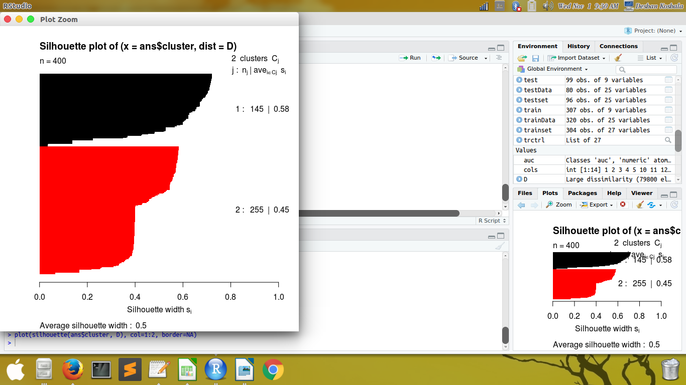

> plot(silhouette(ans$cluster, D), col=1:1, border=NA)

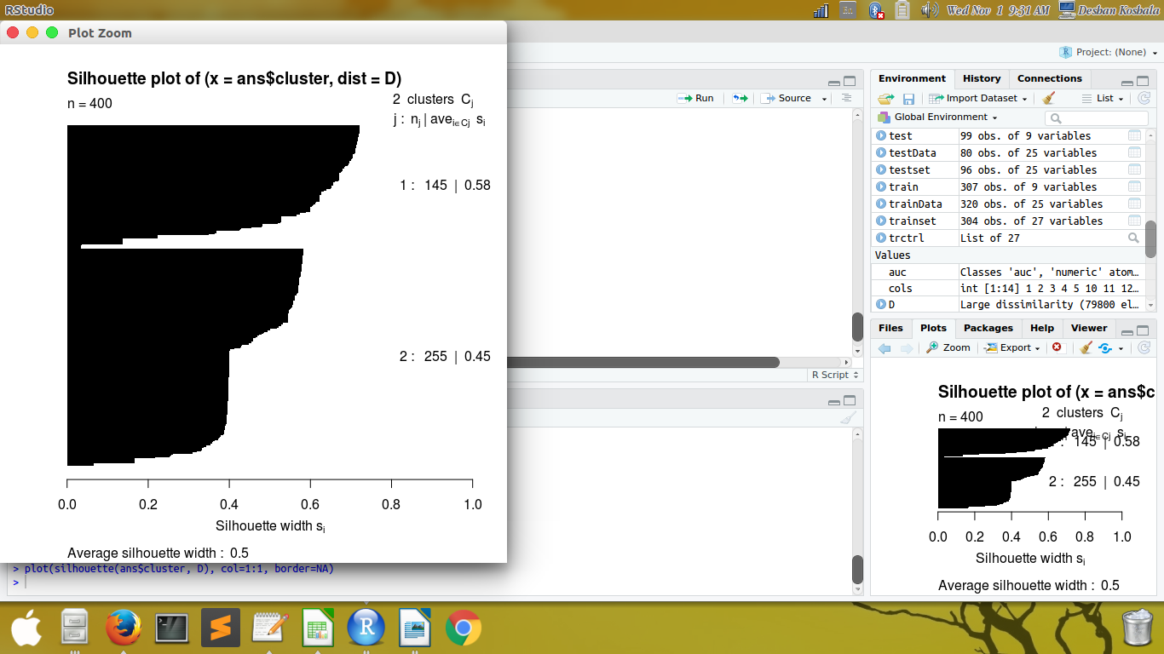

> plot(silhouette(ans$cluster, D), col=2:2, border=NA)

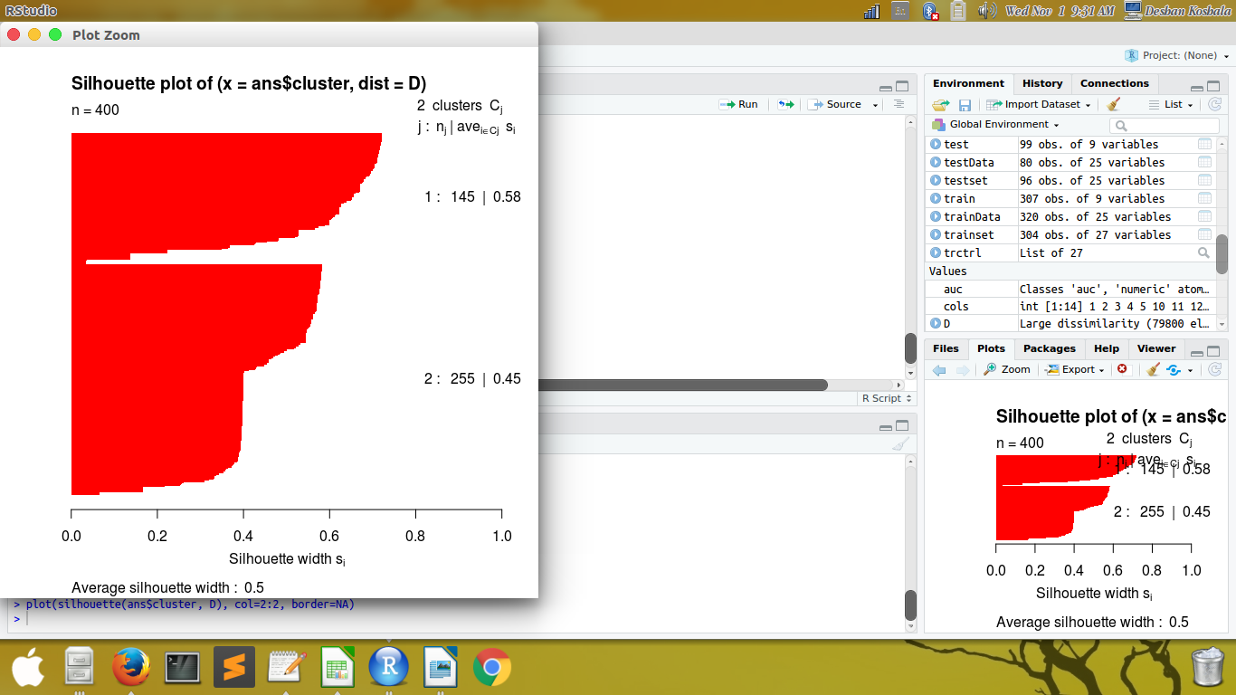

B) K means clustering with k=actual number of classes-1

cols <- c(1:5, 10:18)
ans <- kmeans(kidney_noc[, cols], 1)
ans

K-means clustering with 1 clusters of sizes 400

Cluster means:
age bp sg al su bgr bu sc sod pot hemo pcv
1 51.48337596 76.46907216 1.0177125 0.9 0.395 148.0365169 57.4257218 3.072454295 137.528754 4.62724368 12.52643681 38.8844984
wbcc rbcc
1 8406.122449 4.707434963

Clustering vector:
[1] 1 1 1 1 1 1 1 1 1 1 1 1 1 1 1 1 1 1 1 1 1 1 1 1 1 1 1 1 1 1 1 1 1 1 1 1 1 1 1 1 1 1 1 1 1 1 1 1 1 1 1 1 1 1 1 1 1 1 1 1 1 1 1 1 1 1
[67] 1 1 1 1 1 1 1 1 1 1 1 1 1 1 1 1 1 1 1 1 1 1 1 1 1 1 1 1 1 1 1 1 1 1 1 1 1 1 1 1 1 1 1 1 1 1 1 1 1 1 1 1 1 1 1 1 1 1 1 1 1 1 1 1 1 1
[133] 1 1 1 1 1 1 1 1 1 1 1 1 1 1 1 1 1 1 1 1 1 1 1 1 1 1 1 1 1 1 1 1 1 1 1 1 1 1 1 1 1 1 1 1 1 1 1 1 1 1 1 1 1 1 1 1 1 1 1 1 1 1 1 1 1 1
[199] 1 1 1 1 1 1 1 1 1 1 1 1 1 1 1 1 1 1 1 1 1 1 1 1 1 1 1 1 1 1 1 1 1 1 1 1 1 1 1 1 1 1 1 1 1 1 1 1 1 1 1 1 1 1 1 1 1 1 1 1 1 1 1 1 1 1
[265] 1 1 1 1 1 1 1 1 1 1 1 1 1 1 1 1 1 1 1 1 1 1 1 1 1 1 1 1 1 1 1 1 1 1 1 1 1 1 1 1 1 1 1 1 1 1 1 1 1 1 1 1 1 1 1 1 1 1 1 1 1 1 1 1 1 1
[331] 1 1 1 1 1 1 1 1 1 1 1 1 1 1 1 1 1 1 1 1 1 1 1 1 1 1 1 1 1 1 1 1 1 1 1 1 1 1 1 1 1 1 1 1 1 1 1 1 1 1 1 1 1 1 1 1 1 1 1 1 1 1 1 1 1 1
[397] 1 1 1 1

Within cluster sum of squares by cluster:
[1] 2543757430
(between_SS / total_SS = 0.0 %)

Available components:

[1] "cluster" "centers" "totss" "withinss" "tot.withinss" "betweenss" "size" "iter"
[9] "ifault"

C) K means clustering with k=actual number of classes+1

> cols <- c(1:5, 10:18)
> ans <- kmeans(kidney_noc[, cols], 3)
> ans
K-means clustering with 3 clusters of sizes 12, 111, 277

Cluster means:
age bp sg al su bgr bu sc sod pot hemo
1 52.25000000 71.66666667 1.012500000 2.4166666667 0.5833333333 169.6697098 98.33333333 4.758333333 132.9214590 4.137874000 10.00000000
2 53.21591668 77.80068728 1.017162162 0.9459459459 0.6126126126 155.9489068 53.93742641 2.507565910 138.6257663 4.359782919 12.71987160
3 50.75589759 76.14351110 1.018158845 0.8158844765 0.2996389892 143.9286700 57.05138768 3.225783040 137.2887510 4.755621227 12.55837175
pcv wbcc rbcc
1 29.41666667 17433.333333 3.667286250
2 38.84164405 10299.099099 4.659228378
3 39.31182985 7256.494511 4.771812996

Clustering vector:
[1] 3 3 3 3 3 3 3 3 2 2 3 3 2 3 2 3 3 3 2 3 2 3 3 3 3 3 2 2 3 3 3 3 2 3 3 2 3 3 3 2 2 3 2 3 3 3 3 3 1 1 2 3 3 3 2 3 2 3 3 3 3 3 3 3 3 3
[67] 3 3 3 3 3 1 3 3 3 3 3 3 3 2 2 3 3 3 3 3 3 3 2 3 2 2 3 3 2 3 3 2 3 2 3 2 3 2 3 3 3 2 2 3 2 2 3 2 2 3 3 2 3 3 3 3 3 1 3 3 3 1 3 3 1 2
[133] 2 3 2 3 3 2 3 3 3 3 3 3 2 3 3 1 3 3 3 3 3 1 3 3 3 3 3 2 2 2 3 3 2 3 3 3 3 3 2 2 2 2 3 3 2 3 2 3 3 1 3 3 3 3 3 2 3 3 1 2 3 3 3 3 2 3
[199] 1 2 3 3 3 3 3 3 3 2 3 3 2 3 2 3 3 3 3 2 3 3 2 3 3 2 3 2 3 3 3 1 2 3 3 3 3 3 3 2 3 3 3 3 2 2 2 3 3 3 2 3 2 2 2 3 3 2 2 2 3 3 2 3 3 3
[265] 3 2 3 2 3 3 3 2 3 3 3 3 3 3 2 3 3 2 3 2 3 3 2 3 2 3 3 3 2 3 3 2 3 3 3 2 2 3 3 3 3 2 3 3 3 3 2 3 3 3 2 3 3 3 3 3 2 2 3 3 3 3 3 2 3 3
[331] 3 3 2 3 3 2 2 3 3 3 3 3 3 3 3 3 3 3 3 2 2 2 3 3 3 3 3 2 3 3 3 3 2 3 2 2 2 3 2 2 2 3 2 2 3 2 2 3 3 3 3 3 3 3 2 3 3 3 2 3 3 3 3 3 2 3
[397] 3 3 3 3

Within cluster sum of squares by cluster:
[1] 140094535.8 138132948.2 523753530.0
(between_SS / total_SS = 68.5 %)

Available components:

[1] "cluster" "centers" "totss" "withinss" "tot.withinss" "betweenss" "size" "iter"
[9] "ifault"

D) Density based clustering with the radius parameter

** install.packages(“dbscan”)

library (cluster)
library (dbscan)
cols <- c(1:5, 10:18)
ans <- clara (x=kidney_noc[, cols], k=2)
ans
Call: clara(x = kidney_noc[, cols], k = 2)
Medoids:
age bp sg al su bgr bu sc sod pot hemo pcv wbcc rbcc
[1,] 55 80 1.010 0 0 146 57.425722 3.072454 137.528754 4.627244 9.8 38.884498 8406.122449 4.707435
[2,] 52 80 1.025 0 0 99 25.000000 0.800000 135.000000 3.700000 15.0 52.000000 6300.000000 5.300000
Objective function: 1136.183539
Clustering vector: int [1:400] 1 2 1 2 2 1 1 2 1 1 1 2 1 1 1 2 1 1 ...
Cluster sizes: 279 121
Best sample:
[1] 2 10 38 65 74 76 77 83 90 97 105 123 133 137 144 153 156 160 169 173 175 178 186 203 204 212 219 229 245 257 294 299 304
[34] 311 314 321 346 351 353 354 379 382 391 397

Available components:
[1] "sample" "medoids" "i.med" "clustering" "objective" "clusinfo" "diss" "call" "silinfo" "data"

ans[["clusinfo"]]

size max_diss av_diss isolation
[1,] 279 17994.21259 1251.2729450 8.540413057
[2,] 121 4100.26498 870.8120988 1.946067737

dbscan(kidney_noc[, cols], eps=11047, minPts = 121 )

DBSCAN clustering for 400 objects.
Parameters: eps = 11047, minPts = 121
The clustering contains 1 cluster(s) and 0 noise points.

1
400

Available fields: cluster, eps, minPts

library(cluster)
D<- daisy(kidney_noc[, cols])

plot(silhouette(ans$cluster, D), col=1:1,border=NA)
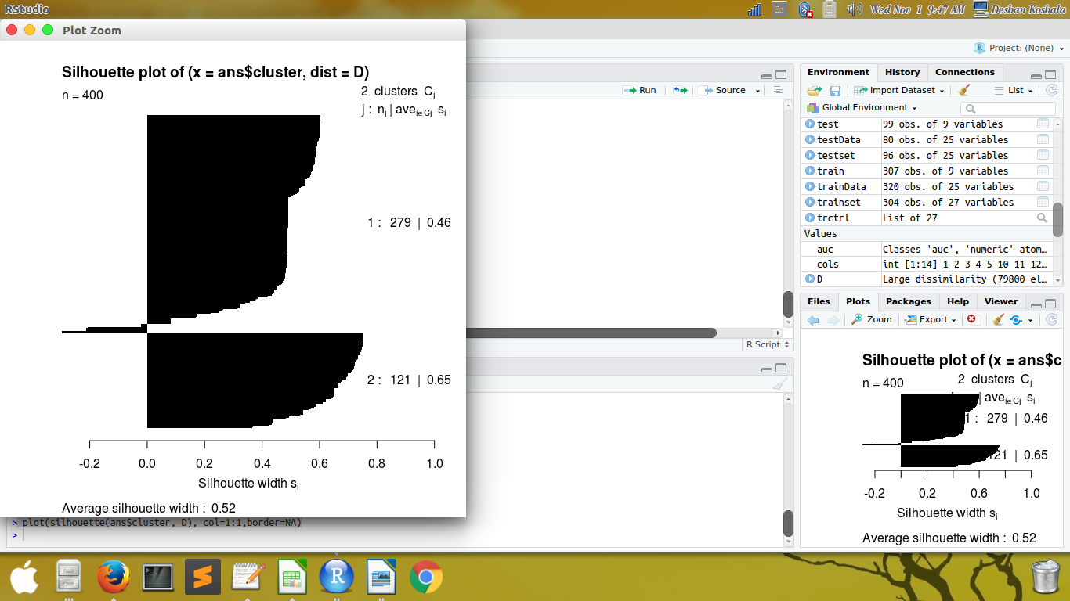

plot(silhouette(ans$cluster, D), col=2:2, border=NA)

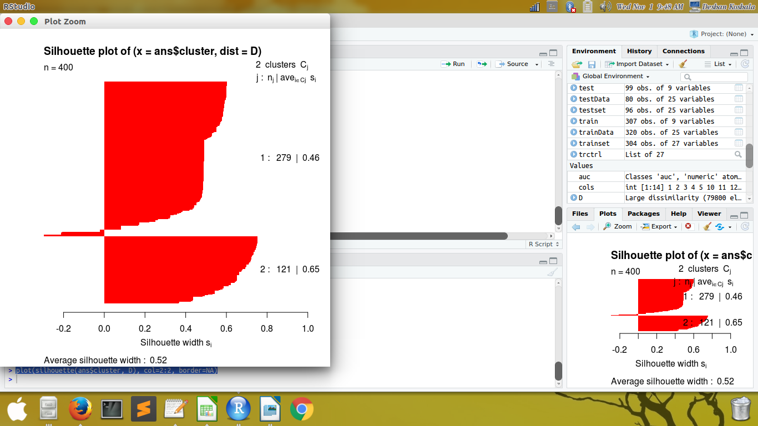

The cluster with highest (between_SS / total_SS) would be the best cluser, accordingly out of the three cases A, B and C , C is the better cluster.

